1265mm from origin to board

I found that the percent error in expected distances versus those found using image processing were much larger than expected and is strongly dependent on the measured distance from the board to the center of rotation of the system. The measurement of this distance was difficult to take and could easily vary by a significant amount.

In the tables below, each row represents a pair of points and the point between them. [x1, y1, x2, y2, xavg, yavg]

1265 distance percent errors

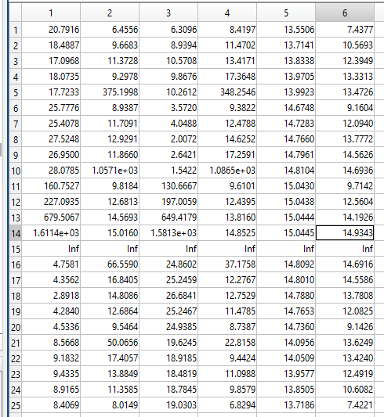

1450mm distance percent errors

